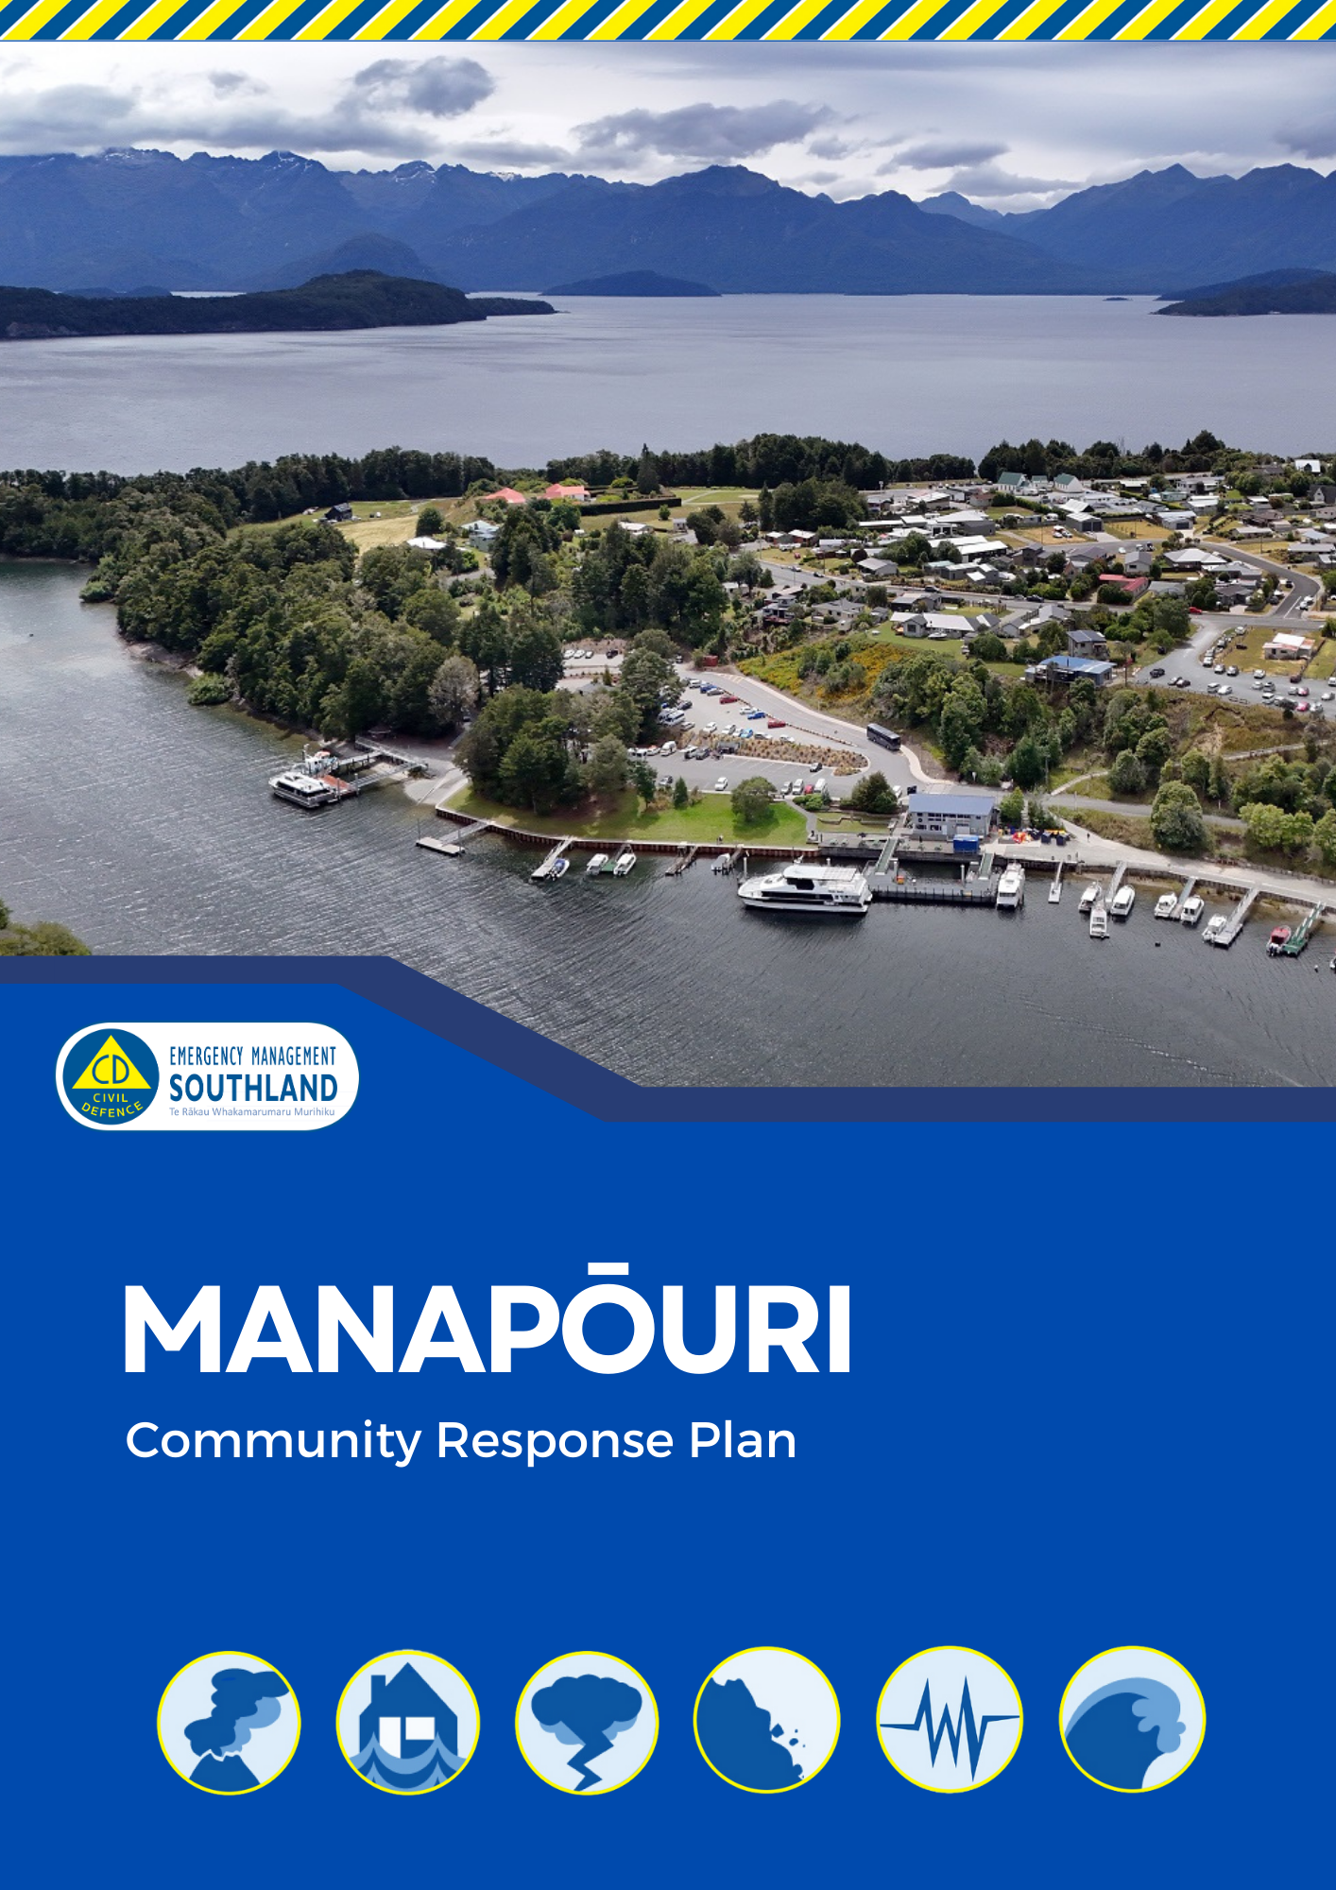
Contents

Manapōuri Community Response Plan 3
How to Stay Informed During an Emergency 3
Purpose of the Community Response Groups 4
Community Details 5
Manapōuri Community Hazard and Risk Summary 8
Key Identified Local Resources 14
Community Emergency Hubs 17
Community Response Group Contact Lists 16
Appendix 1 – AED Locations 17
Appendix 2 - Local Skills and Resources 18
Appendix 3 - Individuals Needing Support During Emergencies 20

This plan is designed to complement and operate in conjunction with the Te Anau Community Response Plan

Printed version is no longer controlled, check EMS website for current plan.
Updated December 2025


Manapōuri Community Response Plan

Emergency Management Southland contact details
- Website: https://www.cdsouthland.nz
- Phone: 0800 76 88 45 or 03 211 5115
- Email: ems@cdsouthland.nz
- Facebook: @cdsouthland (Emergency Management Southland)
- Instagram: @southlandcdem

If you would like to become part of the Manapōuri Community Response Group or have any questions, please contact Emergency Management Southland.

How to Stay Informed During an Emergency

Visit https://cdsouthland.nz/useful-things/ for information on:
- Helpful resources
- Tsunami maps
- Weather
- River heights
- Power outages
- Roads
- Geonet (Earthquake information)

Local radio stations to listen to during an emergency

Station | Frequency
The Hits | Te Anau 90.4FM & rest of Southland 98.8FM
Hokonui | All of Southland 94.8FM
More FM | Te Anau 96.0FM & rest of Southland 89.2FM
Newstalk ZB | All of Southland 864AM
Radio New Zealand | Te Anau 101.6FM, Milford Sound 92.0FM & rest of Southland 101.2FM
Radio Southland | All of Southland 96.4FM

Antenno


Receive notifications direct to your phone on council services, flood warnings, hazards, roadworks, service disruptions, community events, and more. You can also use Antenno to tell us about things that need our attention, or give us feedback, direct through the app. Antenno is available for free for iPhone and Android devices. Setup is easy and doesn’t require signing-up.

Purpose of the Community Response Groups

Community Response Groups planning for an emergency

The more prepared a community is, the more likely it is that the community will be able to look after themselves and others. This plan contains a short demographic description of the Manapōuri area, information about key hazards and risks, information about Emergency Community Emergency Hubs, where the community can gather, and important contact information to help the community respond effectively. Members of the Manapōuri Community Response Group, along with Emergency Management Southland staff, have developed the information contained in this plan. The plan is a living document and can be updated at any time through Emergency Management Southland.

Community Response Groups during an emergency

During an emergency response, the Community Response Group will be Emergency Management Southland’s first point of community contact in an emergency, therefore they play a crucial role in supporting affected communities. The Group will be asked if they think there is a need to activate by Emergency Management Southland, and have the capacity to do so, or they are able to self-activate to provide immediate short-term assistance during an emergency. The Community Response Group works closely with Emergency Management Southland to ensure that resources are effectively distributed and that vulnerable populations are identified and supported. By leveraging local knowledge and networks, the Community Response Group helps to maintain a safe place, communicate vital information, and foster community resilience, ensuring a coordinated and compassionate response to an emergency.

Community Response Groups into recovery

Community Response Groups will be vital during the recovery of a community. They will be able to act as a connection between the community and the recovery team. They will have key local knowledge and understand the effects of decisions on the local community and will be able to identify areas of most importance to the community and suggest ways to work towards the communities’ end goals. The process around community recovery will be described in greater depth in the Southland Recovery Plan which can be found on our website: https://www.cdsouthland.nz


Community Details

Demographic details

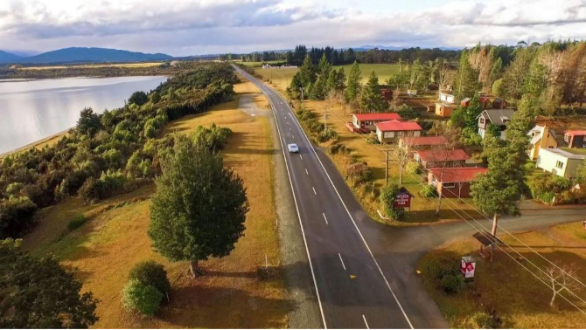
Manapōuri is a small lakeside township in the Fiordland region of Southland, located about 20 kilometres south of Te Anau. Nestled on the eastern shores of Lake Manapōuri and at the edge of Fiordland National Park, it serves as one of the main gateways to Doubtful Sound / Patea and the wider Fiordland wilderness. The settlement is surrounded by dramatic alpine scenery, with the Hunter Mountains and Cathedral Peaks forming a striking backdrop.
Manapōuri has an estimated population of around 270 people (2023), showing steady growth from previous census years. The town has a higher median age (56 years) than the national average, reflecting a smaller working-age population and a community with a mix of long-term residents, retirees, and seasonal tourism workers.
Tourism and hydroelectric power are central to the town’s identity and economy. The Manapōuri Hydroelectric Power Station, located underground near West Arm, is one of New Zealand’s most significant renewable energy assets. The town also supports eco-tourism, fishing, tramping, and scenic tours, with strong connections to conservation and sustainable resource use.
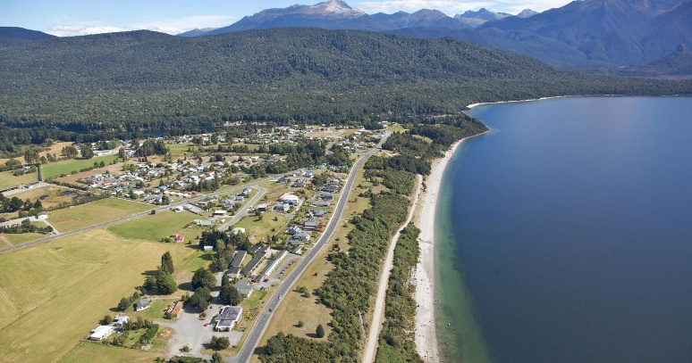
Housing in Manapōuri is predominantly owner-occupied. The area is serviced by basic amenities and modern telecommunications, though with some limitations typical of remote settlements. The community is known for its resilience and strong local networks, a valuable asset in managing the risks associated with natural hazards such as flooding, landslides, and earthquakes that can affect Fiordland.

Identified potential vulnerable sub communities
Emergencies affect all of us. Depending on the nature, extent and timing of an emergency, some people can be more affected than others. We need to ensure equity in response to improve assistance to all in the community. Groups who may need consideration include:

- Elderly within the community.
- People who need power for medical reaons. This could include daily care and individuals recovering from surgery needing district nursing visits, mental health, dialysis patients, oxygen dependant patients or any other medically dependant reason.
- Expectant Mums.
- Tourist. This could include day visitors, AirBnB guest houses (approx 38), motor camp, lake/ boat day users and Doubtful Sound visitors.
- Motorists traveling around Blackmount Hill.
- Groups at Deep Cove or Te Kōawa Lodge.
- Tramping and DOC hut occupants.
- Large population of holiday homes with people from outside of Fiordland.
- Lower socio-economic individuals within the community.
- People living on their own within the community.
- New people recently moved to Manapōuri community.

Neighbouring communities

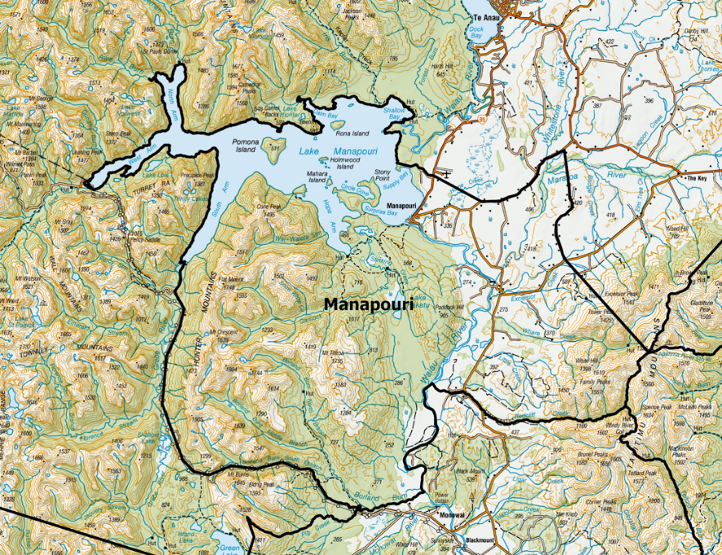
In an emergency, it's important that neighbouring communities work together to support each other. Nearby communities can provide help if your own community is overwhelmed or unable to meet all its needs. This might include sharing resources like emergency shelters, equipment, vehicles, or trained personnel. Likewise, your community may assist others by sending support when they are in need. Reach out to the following communities during an emergency:

- Te Anau
- Milford Sound
- Mararoa
- Blackmount
- Borland Lodge
- Monowai
- Doubtful Sound

Significant local treasures/ assists

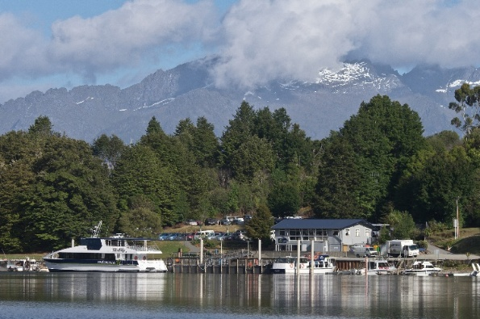
Every community has special places, items, or traditions that are important to its identity — such as marae, historic buildings, taonga, community centres, or natural landmarks. These are considered significant local treasures, and while protecting people is always the top priority during a natural disaster, it's also worth planning how to protect these treasures if it's safe to do so. Following local treasures have been identified by the community:
- Murrell Grand View House
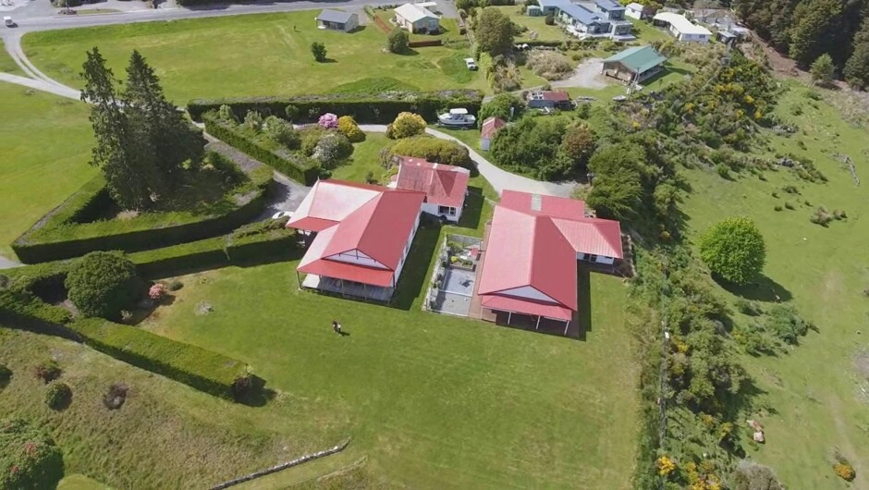
- Buildings by the boat harbour

Manapōuri Community Hazard and Risk Summary

Overview

Hazard and risk information serves to provide a clear understanding of the potential dangers that could impact the community. These hazards and risks outline the nature, characteristics, and potential effects of the hazard, which is crucial to gain an understanding of the dangers the community faces.

Manapōuri is exposed to a number of natural and infrastructure-related hazards. Because of its lakeside location (Lake Manapōuri), steep surrounding terrain, limited road access and important river/bridge infrastructure, the community should be aware of the following as potential threats.

- Flooding

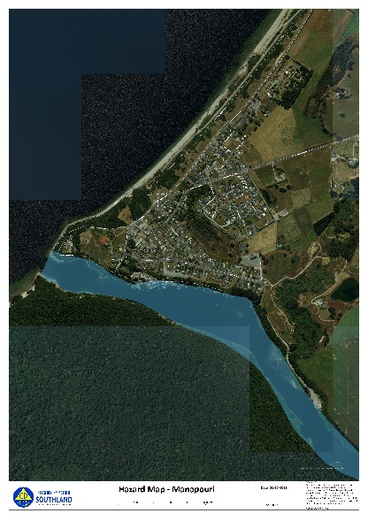
- Risk Level (Priority): High
- Description: Heavy rainfall and increased inflows to Lake Manapōuri and its feeder rivers can raise the Manapōuri Lake levels and Waiau River. This can threaten critical infrastructure, lakeshore properties, low-lying areas, and local roads. Flooding can isolate parts of the community by impacting access roads or bridges around the area, especially if combined with other hazards.
- Impacts: Property damage, road closures, isolation, damage to property and potential evacuation.
- Mitigation Strategies:
  - Maintain drainage systems.
  - Elevate important items in flood-prone areas.
  - Prepare sandbags or barriers.
  - Have an Emergency Plan which includes household emergency kit and supplies.
  - Be prepared to evacuate.
- Map Reference: For flood risk maps, refer to Environment Southland's hazard portal: https://experience.arcgis.com/experience/9e4fee97e31e47c3a32f6f152be51d34/page/Property-Search

- Landslide & Slope Instability

- Risk Level (Priority): Medium
- Description: The steep slopes around Lake Manapōuri have been identified as having “high to very high landslide susceptibility”. Heavy rainfall, earthquake shaking, or soil saturation could trigger shallow or deeper slopes failures, threatening roads, tracks, and properties built on or below slopes.
- Impacts: Road blockages, isolation, damage to property, disruption to power and communications, risk to life and injury, increased lake hazards such as tsunami.
- Mitigation Strategies:
  - Stay alert during heavy rain or earthquakes.
  - Report cracks, slumping or new movement.
  - Avoid parking or storing gear at the base of step banks.
  - Know alternative routes.
  - Have an Emergency Plan which includes household emergency kit and supplies.
  - Support vegetation on slopes.

- Earthquake

- Risk Level (Priority): Medium
- Description: The wider Fiordland / Southland region including Manapōuri is susceptible to seismic activity, both the Alpine Fault and local faults can have major impact on the community. A strong earthquake could damage buildings, roads, bridges, utilities (water, power), and local infrastructure. Liquefaction or ground instability is a concern where soils are saturated or unstable, especially near waterways or lake edges. This may affect building foundations, roads, and bridges. Earthquakes may also trigger landslides on steep slopes, compounding risk.
- Impacts: Building damage, power outages, road disruptions, food network disruption, lack of resources and potential landslides.
- Mitigation Strategies:
  - Secure heavy furniture and appliances.
  - Have an Emergency Plan which includes household emergency kit and supplies.
  - Be self-sufficient and able to cope without outside assistance.
  - Practice "Drop, Cover, Hold" drills.
- Map Reference: For New Zealand’s active faults map, refer to GNS Science: https://www.gns.cri.nz/data-and-resources/new-zealand-active-faults-map/

- Critical Infrastructure Failure (E.G. Transport, power and communications access)

- Risk Level (Priority): Medium
- Description: Key roads and bridges (especially those crossing rivers feeding into or out of the lake) are critical lifelines. Flooding, landslides or earthquake damage may wash out or block bridges and roads, isolating parts of the community or preventing emergency access. High rainfall, high winds and slips can cause road blockages from fallen trees, erosion or surface damage, posing risks for residents, visitors, and emergency services. During a major event power, phone, and other services may fail.
- Impacts: Roads becoming blocked or damaged, bridge failure or closure, phone and internet outages, communication delays, isolation or unable to return, Unable to phone out to get help or advice.

- Mitigation Strategies:
  - Be self-sufficient and able to cope without outside assistance.
  - Have an Emergency Plan which includes household emergency kit and supplies.
  - Cell phones may still work however have an alternative communication method. E.G. VHF Radios and operators.
  - Know the alternative roads or travel routes.
  - Keep vehicles fuelled.

- Severe Weather

- Risk Level (Priority): High
- Description: Fiordland & Southland weather patterns occasionally bring extreme rainfall, strong winds, and heavy snow — all of which can trigger floods, slips, road hazards, and isolation. Storms may also damage trees and infrastructure and worsen risk of landslides or flooding.
- Impacts: Power outages, flooding, fallen trees, transportation disruption with road closures, disruption to essential services and damage to homes and farms.
- Mitigation Strategies:
  - Regularly inspect and maintain roofs, gutters and structures.
  - Trim trees near power lines.
  - Prepare alternative heating and lighting sources.
  - Stockpile essential supplies.
  - Stay informed through weather alerts.
  - Avoid non-essential travel during severe conditions.

- Tsunami

- Risk Level (Priority): Medium
- Description: A significant slope failure or rockslide into Lake Manapōuri could displace water and generate a local “lake tsunami” (seiche), causing sudden waves and lake surges. Such a wave could inundate lakeshore areas, wharves, boat ramps, and homes close to the water.
- Impacts: Sudden, fast-moving waves, Flooding at lower Murrell Ave. and along Waiau St. along river side, damage to wharves, boat ramps, jetties and marina structures, boats being swamped, swept away or damaged, erosion on lake edge, debris washed inland.
- Mitigation Strategies:
  - Stay away from the lake edge during or after earthquakes.
  - Avoid the shoreline during heavy rain.
  - Know the natural warning signs and move uphill and away from the lake.
  - Have an Emergency Plan which includes household emergency kit and supplies.
  - Assist displaced people and if needed make emergency shelter and food available where possible.

Compound and Cascading Hazards

Because many hazards overlap (E.G. heavy rain → flooding + landslide; earthquake → slope failure + liquefaction + lake surge), a single event can trigger a cascade of hazards. For example, an earthquake may destabilize slopes, cause landslides into the lake, generate waves, damage roads and isolate the community — while also damaging utilities.

Hazard risk summary table
Hazard | Likelihood | Impact | Priority
Flooding | High | High | High
Landslide & Slope Instability | Medium | High | Medium
Earthquake | Medium | High | Medium
Critical Infrastructure Failure | Medium | High | Medium
Severe Weather | High | High | High
Tsunami | Low | High | Medium

- Likelihood: Probability that the hazard will occur in or impact Manapōuri.
- Impact: The scale of consequences the hazard would have on the community (people, infrastructure, economy, environment).
- Note: This assessment has been based on qualitative judgment and local context to guide how likelihood and impact are rated. For example, flooding is “High” likelihood in Manapōuri due to known historical events, even if flood defences are present.

Maps and diagrams (Useful links)

- Environment Southland Hazard Summaries: Comprehensive summaries of various hazards affecting towns in Southland, including Manapōuri. It provides detailed flood risk maps for Manapōuri, illustrating areas susceptible to flooding: https://maps.es.govt.nz
- Seismic Hazard Maps: The New Zealand National Seismic Hazard Model offers maps indicating earthquake probabilities across regions: https://www.gns.cri.nz
- Natural Hazards Portal: The Natural Hazards Portal allows exploration of various hazard risks and historical claims data: https://www.naturalhazardsportal.govt.nz

Identified local critical infrastructure/ vulnerabilities

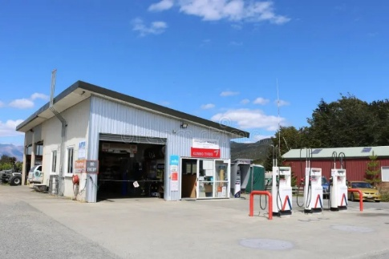
Critical infrastructure refers to essential facilities and systems that support the functioning and wellbeing of the community. Damage to or disruption of these assets during an emergency could significantly impact Manapōuri’s ability to respond and recover.

- Manapōuri Water Treatment Plant – View Street
- Allied Fuel Stop Manapōuri - Waiau Street
- Cell phone towers – Freestone Hill.
- Local power supply – Lines.
- Te Anau Airport Manapōuri - Aviation Drive.
- Food supply – E.G. The Church Manapōuri, Waiau Street Café, Manapōuri Store & Cathedral Café.
- Refuse/Rubbish - Hillside Road recycle and rubbish.

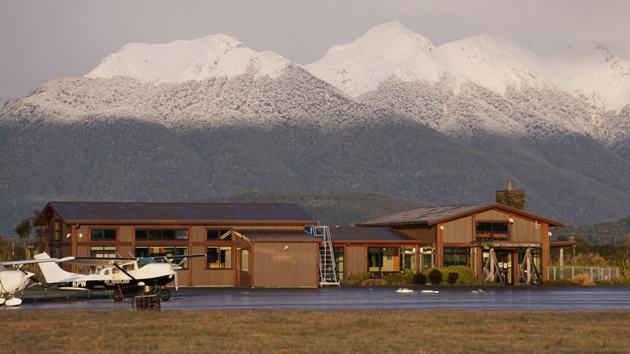

Key Identified Local Resources

The resources listed in this plan are key examples intended to support community preparedness and response. While they represent a broad range of services and support networks, they are not a comprehensive list. Communities are encouraged to identify and connect with additional local organisations, cultural groups, and informal networks that play vital roles in resilience and wellbeing.

Key Local Emergency Service contacts - For urgent matters please dial 111
Organisation | Name | Phone | Address | Other details
Police – Te Anau |  | 03 249 7600 | 196 Milford Rd,  Te Anau 9600
FENZ – CFO | Ray Haanen | 03 249 6830  027 221 4503 | 45 Hillside Manapōuri Road, Manapōuri 9679 | ray.haanen@fireandemergency.nz
St John – Group Operations Manager – Southland West | Kat Andrews | 027 291 5462 | 25 Luxmore Drive, Te Anau 9600 | katrina.andrew@stjohn.org.nz
ES Harbourmaster | Lyndon Cleaver | 03 211 5115 | Cnr North Rd &, Price Street, Waikiwi, Invercargill 9810

Southland District Council
Organisation | Phone | Address | Other details
Manapōuri Waste Water Treatment Plant | 0800 732 732 | 65 View Street, Manapōuri 9679 | sdc@southlanddc.govt.nz
Community Partnership Leader – Stella O’Connor | 0800 732 732 | 15 Forth Street, Invercargill 9810 | stella.oconnor@southlanddc.govt.nz
Fiordland Community Board local – Julie Burgess | 021 354 410 | 3 Waiau Street, Manapōuri 9679 | julieburgess63@yahoo.co.nz

Medical and support agencies
Organisation | Phone | Address | Other details

Utility services and supplies
Organisation | Phone | Address | Other details
Manapōuri Diggers Ltd | 021 721 591

Service stations, supermarkets and food establishments
Organisation | Phone | Address | Other details
The Church Manapōuri | 03 249 6903 | 23 Waiau Street, Manapōuri 9679 | ssManapōuri@gmail.com
Manapōuri Motors 2018 LTD | 03 249 6644 | 31 Waiau Street, Manapōuri 9679 | Manapōurimotors@xtra.co.nz
Waiau Street Café | 03 249 6934 | 64 Waiau Street, Pearl Harbour, Manapōuri 9679
Manapōuri Store & Cathedral Cafe | 03 249 6619 | 29 Waiau Street, Manapōuri 9679

Education providers, rest home, marae, faith and community organisations
Organisation | Phone | Address | Other details
Manapōuri Art Group | 021 186 7732 |  | awhatleynz@gmail.com
Manapōuri Boat Club | 021 149 2465 | 125 View Street, Manapōuri 9643 | Manapōuriboatclub@gmail.com
Marakura Yacht Club | 03 249 7450 | 96 Manapōuri-Te Anau Highway, Te Anau | secretary@marakura.org
Manapōuri Community Hall |  | 11 Hall Road, Manapōuri 9679

Additional resources
Organisation | Phone | Address | Other details
Design & Make Architects | 03 422 4289 | 1085D Manapōuri Hillside Rd, Te Anau 9679 | admin@designmake.co.nz
Home Creek Nursery | 03 249 6680 | 295 Hillside-Manapōuri Road, Te Anau 9679 | plants@homecreeknursery.co.nz
Kepler Mountain View Alpacas | 027 354 5960 | 130 Hillside-Manapōuri Road, Manapōuri 9679 | bookings@kmv.co.nz
Manapōuri Community Pool | 021 168 7186 | 17 Hall Road, Manapōuri 9679 | Manapōuripool@gmail.com
Manapōuri Holiday Park | 027 214 3999 | 86 Cathedral Drive, Manapōuri 9643 | hello@Manapōuripark.com
Manapōuri Lakeview Motor Inn | 0800 89 62 62 | 68 Cathedral Drive, Manapōuri 9679 | reservations@Manapōuri.com
Manapōuri NZMCA Park |  | 170 Hillside-Manapōuri Road, Manapōuri 9679 | Manapōurirvpark@gmail.com
Adventure Manapōuri River Taxi | 0800 456 457 | 77 Manapōuri – Te Anau Highway, Manapōuri 9679 | info@adventureManapōuri.co.nz
RealNZ: Pearl Harbour | 03 249 6602 | 64 Waiau Street, Pearl Harbour, Manapōuri 9679
The Two Wee Bookshops | 03 249 6664 | 1 Home Street, Manapōuri 9679 | twoweebookshops@gmail.com
Time Traders | 022 426 2266 | 23 Waiau Street, Manapōuri 9643 | timetraders2020@gmail.com

Community Emergency Hubs

Community Emergency Hubs provide pre-identified places where the community can gather in the event of an emergency. Not all hubs will be suitable during an emergency, and it is up to the community to decide at the time. It is possible that a new venue will need to be found, but the concept of a location where the community gather is vital during a response as people seek immediate support, shelter, comfort and information.

Each pre-determined location will be provided with an Emergency Community Hub Guide and be able to access advice from Emergency Management Southland if they require further information or support. Contact information for the hubs will be available on the following page.

Community Emergency Hub key holders
Name | Phone | Address | Key Holders
Main
Manapōuri Community Hall | 022 190 2071 | 11 Hall Road, Manapōuri 9679 | - Laura Harwood – 021 080 19150  - Julie Burgess - 021 354 410  - Angie Campbell – 021 168 7186  - Manapōuri Store & Cathedral Café (Annette)  - Manapōuri Motors 2018 Ltd (Grant and Ange)  - Lockbox code – Contact any of the above.

Basic items for a Community Emergency Hub

When opening a Community Emergency Hub, it's essential to bring basic items to support coordination, communication, and community-led response. These items are critical to help the community self-organise, share information, and meet urgent needs during a disaster when emergency services may be delayed. These items may include:

- Water
- Tea, coffee, milk
- Food
- Toilet paper
- First aid kits
- Blankets
- Torches
- Lighters
- BBQ/ LPG bottle
- Games
- Lighting
- Generators/ fuel
- Anything else that you feel is appropriate

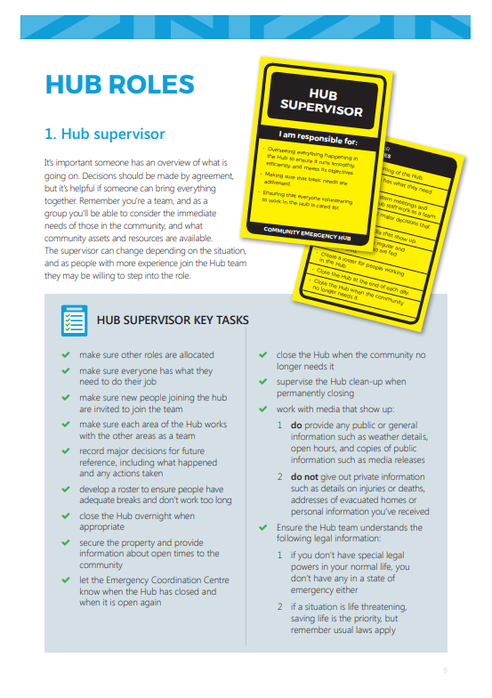
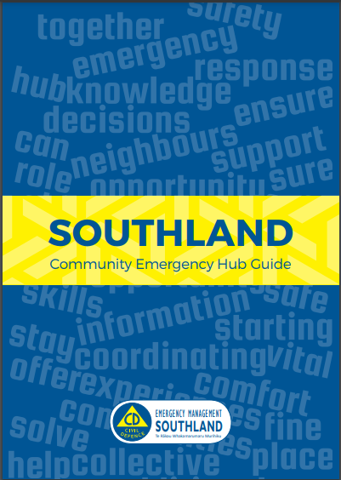
Refer to Southland Community Emergency Hub Guide for more information on the set up and running of a Community Emergency Hub during an emergency response.

Community VHF Radio

A community VHF radio (Very High Frequency radio) is a key tool for communication during emergencies, especially when other forms of communication, like mobile phones or landlines, are unavailable due to network failures or power outages. This can be a communities only way to communicate with the Emergency Coordination Centre (ECC) if telecommunications have been disrupted due to an emergency event. Training to become familiar can be provided. Instructions on how the VHF radio are attached to the radio.

Name | Place | Address | Key Holders
Manapōuri Community VHF Radio | Manapōuri Fire Station | 45 Hillside Manapōuri Road, Manapōuri 9679 | Ray Haanen - 027 221 4503  Any member of the Manapōuri Fire Brigade

Community Response Group Contact Lists
Emergency Management Southland
Name | Phone | Email | Other details
EMS Duty Advisor | 03 211 5411  0800 76 88 45 | ems@cdsouthland.nz | 24/7 monitoring and on call for all enquiries
Emergency Management Advisor | 021 300 272 | oliver.todd@cdsouthland.nz | Oliver Todd - Liaison with the community of Manapōuri

Key Community Response Group members
Name | Phone | Email | Other details
Julie Burgess
Alistair Burgess
Avis Peters
Dave Kelly
Jacky Holmes
Lesley Schwamm
Paula and Aaron Nicholson
Robin Peters
Pam Smith
Tony Andrew
Katrina Andrew
Lila Roy
Shirley Smith
Sheena Pottinger
Steven Pearce
Alastair McMurray
Ray Haanen
Annette Taylor
Angie Campbell
Grant and Ange Newton
Laura Harwood

Appendix 1 – AED Locations

The table below lists the Automated External Defibrillators (AEDs) available within the community, including their locations and access arrangements as of December 2025. Refer to the website for updated locations: https://aedlocations.co.nz
Organisation | Address | Phone | Location | Opening Hours
AED Location  RealNZ: Pearl Harbour | 64 Waiau Street,  Manapōuri 9679 |  | Doutful Sound Manapōuri Visitor Centre | Mon-Fri: 9am-5pm  Sat: Closed  Sun: Closed
AED Location  Manapōuri Motorhome & Caravan Park | 170 Hillside-Manapōuri Road, Manapōuri 9679 |  | AED by rear door - Electric bike charging area. | Available 24/7
AED Location  Fire Station | 45 Hillside-Manapōuri Road,  Manapōuri 9679 | 111 |  | Not specified. The AED may not be available at certain times.
Te Anau Airport Manapōuri | 77 Aviation Drive,  Manapōuri 9679 | 027 477 1280 Not answered 24/7 | Secure Cabinet front door of the terminal building | Available 24/7
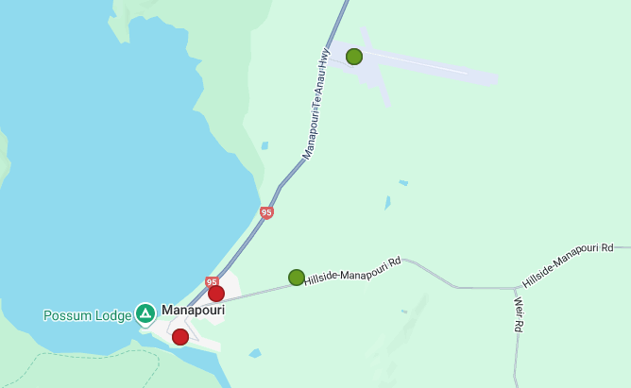

Appendix 2 - Local Skills and Resources

The following table outlines the range of skills, qualifications, and practical resources held by individuals within the community. This includes professional expertise, volunteer experience, equipment, and other capabilities that may support response and recovery activities.

The table is not exhaustive, but it provides a useful snapshot of the people and assets available locally.

Skill/Resource | Name | Contact Details | Address
Medic | Katrina Andrew
Trained First Aider | Lance Shaw
Trained First Aider | Shirley Smith
Trained First Aider | Cliff Barnes
Trained First Aider | Mark and Angie Campbell
Trained First Aider | Diana Keith
Trained First Aider | Tony Andrew
VHF radio | Lance Shaw
VHF radio | Lex Mouat
Starlink | Gaven Burgess  (Te Anau Helicopters)
4x4 owner/driver | Dave Kelly
4x4 owner/driver | Alister Burgess
Chainsaw owner/operator | Jimmy Calder
Chainsaw owner/operator | Dave Kelly
Chainsaw owner/operator | Alistair Burgess
Water/food supplies | The Church Manapōuri
Water/food supplies | Waiau Street Café
Water/food supplies | Manapōuri Store & Cathedral Cafe
Tip truck  diggers | Dave Kelly

Appendix 3 - Individuals Needing Support During Emergencies

The table below identifies community members who may require additional assistance during an emergency. This includes people with mobility or health needs, those living alone who may find it hard and others who may be more vulnerable to disruption.

Name | Address | Phone | Assistance Needed

